Fashion For The Fall

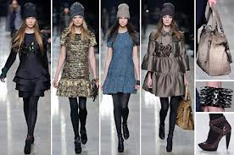

***Be a fashionista this winter with the latest and cheapest trends and the word out on the street on what to wear from ladies like you!***

Among the Hustle and the bustle of the busy city of Los Angeles there is a need to dress to impress. With Los Angeles being one of the capitals of fashion we can all agree that at times it is hard to stay with the hottest and latest trends without hurting our pockets.

So what’s in this fall girls and where can we find what celebrities are wearing for a cheaper price of the cost and still manage to look sheik. But how do the latest trends get to the department stores?

Karina Varela, a buyer of women’s clothing at the ROSS corporate buying store in the heart of LA has got some of the answers for us. “What I look for this winter when choosing our merchandise at ROSS is simply quality at its finest” When I asked how she identified “quality” she stated “Simple us buyers have to go Comm shopping. I go to different competitor stores and high off retailers and I look at the latest trends and work deals with the vendors to be able to get those latest trends for our cheaper price”.

I then asked Karina what she had bought for Ross this Christmas and she said “Definitely our shoppers look for clothes that can keep them warm, so this winter I decided to bring in Coats from vendors like Calvin Klein, BCBG, ANN Taylor, and Alfani. In addition,” this season in particular women are looking for those boots to keep them warm. ROSS carries a variety of high Knee boots, Low boots, heel boots, and rain boots for a fraction of what their original vendors are going for.

Buyers like Karina Varela job is to please their consumer and deliver the hottest trends for cheaper. Nevertheless, this season don’t be stuck with the “IDK what to wear today” phrase. Layer up and have fun with it. But, don’t worry if you don’t have money to go out and buy for this season! You can always improvise with what you already have hanging in your closet and create a fabulous outfit. Here is what other girls are doing this winter.

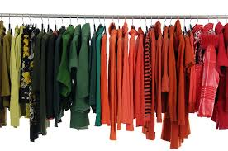

Ana Sosa of 24, is a student and believes that fashion is an art and really identifies who you are as a person. When I asked Ana what she thought was in this season she stated “I love dressing in layers because So Cal weather you just never know…. Its 40 degrees when you wake up but there is always a possibility that by 2 p.m., it will be 75 degrees. This winter I stay in style with layers of dark clothing like black, gray, and blue” stated Ana. “I don’t really have money this year to go out and buy a whole wardrobe so this year I just bought a pair of low heel boots that are in style and they go with my jeans and a coat. That will always be in style”.

Yesenia Garcia of 21 is also a student and thinks that fashion really brings out your true personality. This winter she said she will be sporting beanies, coats, scarfs, jackets, and boots. When I asked her how she identified her taste in fashion she responded “girly biker chick” then I asked what her typical ensemble looked like.

“I feel that even when it’s a casual day and its cold in the winter you still got to keep your fashion edge and this year you can catch me wearing my combat boots with my leather jacket and some jeans” said Yesenia.

Yesenia Morales 25 is a Manager in training at Toyota and her fashion is all about professionalism.

“It is hard to look professional, be warm, and also look fashionable at the same time”. This year for winter you can find me at Ross, TJ Max, Nordstrom’s rack, and Marshalls. When I asked her what her wardrobe looked like for this fall she told me “coats, coats, coats are a must for me this season”. Also, pencil skirts with nylons and high heel boots are definitely in style this year at the office. I can stay warm and look fashionable, elegant, and warm.

Gaby Castaneda is 22 years old and she blogs about fashion all the time. Gabby believes that fashion is a way of life and said that she would die if the malls would close down. Gabby is currently a student and works at BEBE. When I asked her what she was wearing this winter season she told me “high wasted skater skirts with tights and ankle booties, crop sweaters, dark lips, and a colored coat”. Talk about a fashionista.

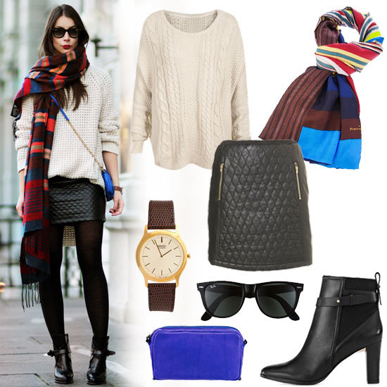

When it comes to fall as you can see it is time to take out those coats, beanies, and scarfs or go out and buy them at your cheaper retailing stores. However, for this winter season you must have a pair of boots, dark lipstick, and a coat. If you have this in your closet you will be set and in fashion this season. Layer it up girls!